Github account

1.username= hkumar7878

password; Pyramid123#

email: [hitesh.ghai@hotmail.com](mailto:hitesh.ghai@hotmail.com)

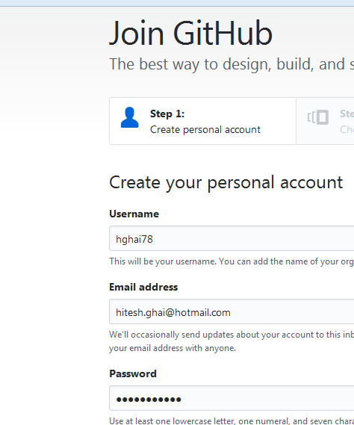

New user name: hkumar7878

**First Way**

**How to set up a permission to push (check in) the code from local machine to git repository.**

In order to perform this task, we have to generate the SSH key. Following is the process.

1. Go to Settings

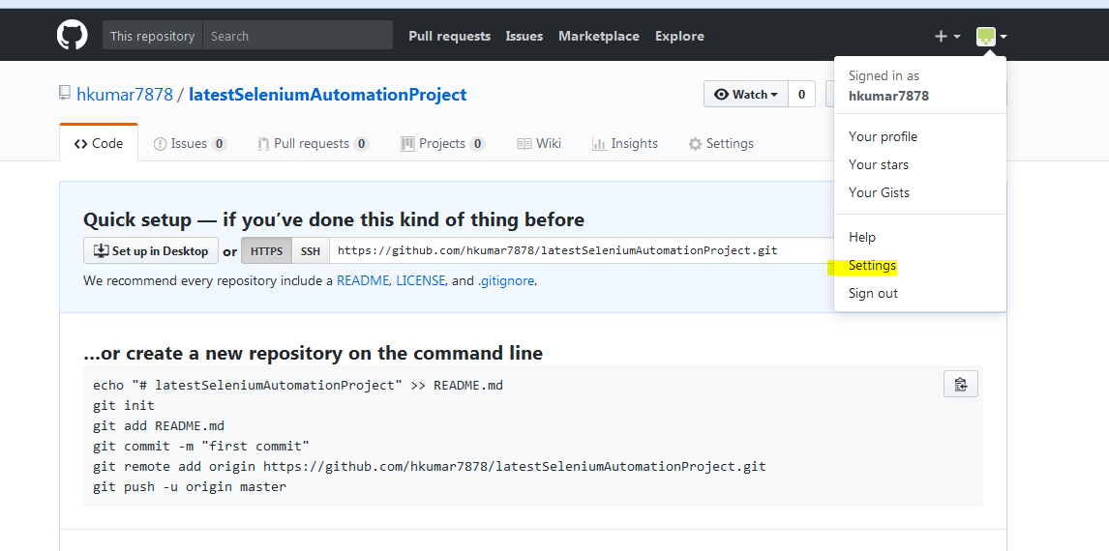

1. Click on following link

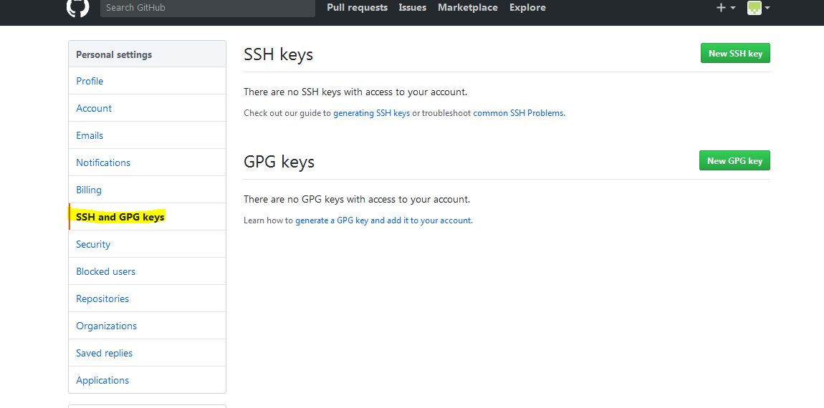

**Second Way:**

Step 1: Navigate Team🡪Share Project.

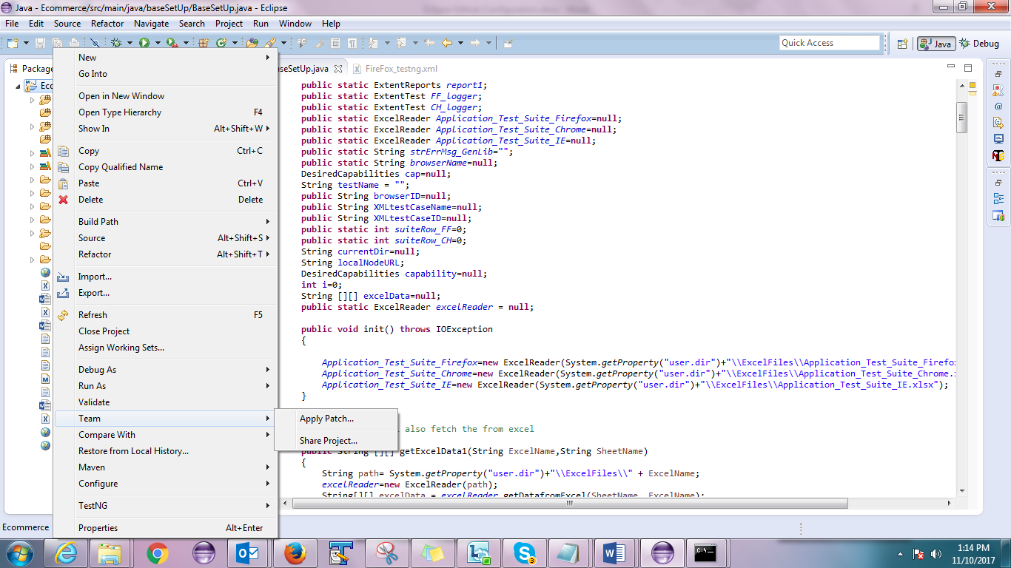

Step 2: Selec Git

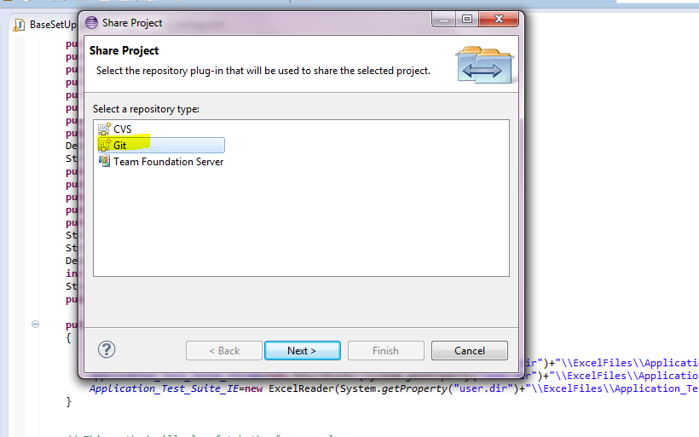

Step 3: Click on Create button

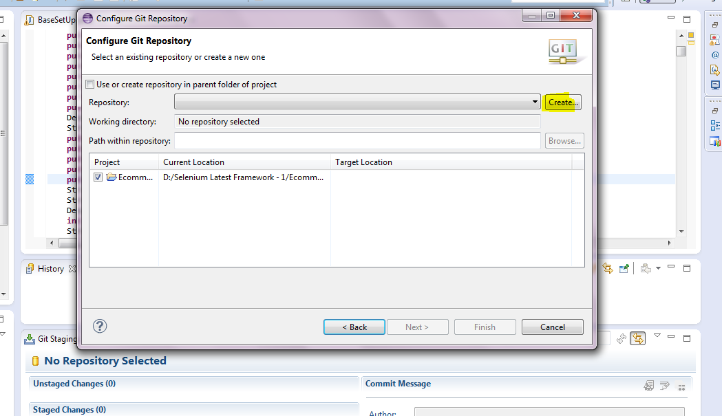

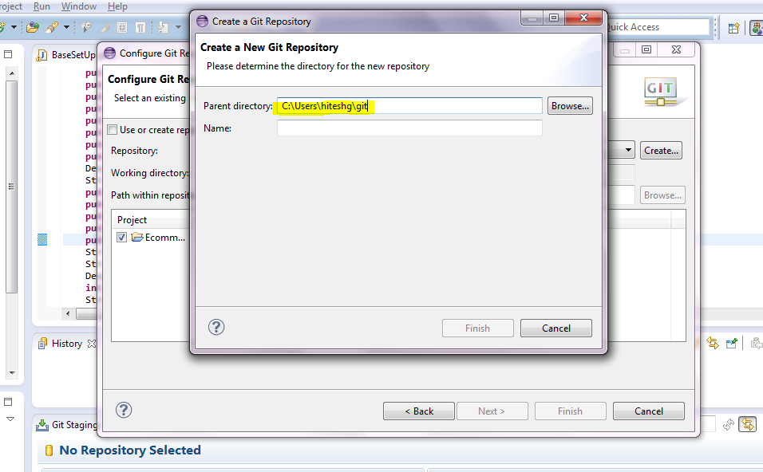

Keep the same directory as above and provide any valid name